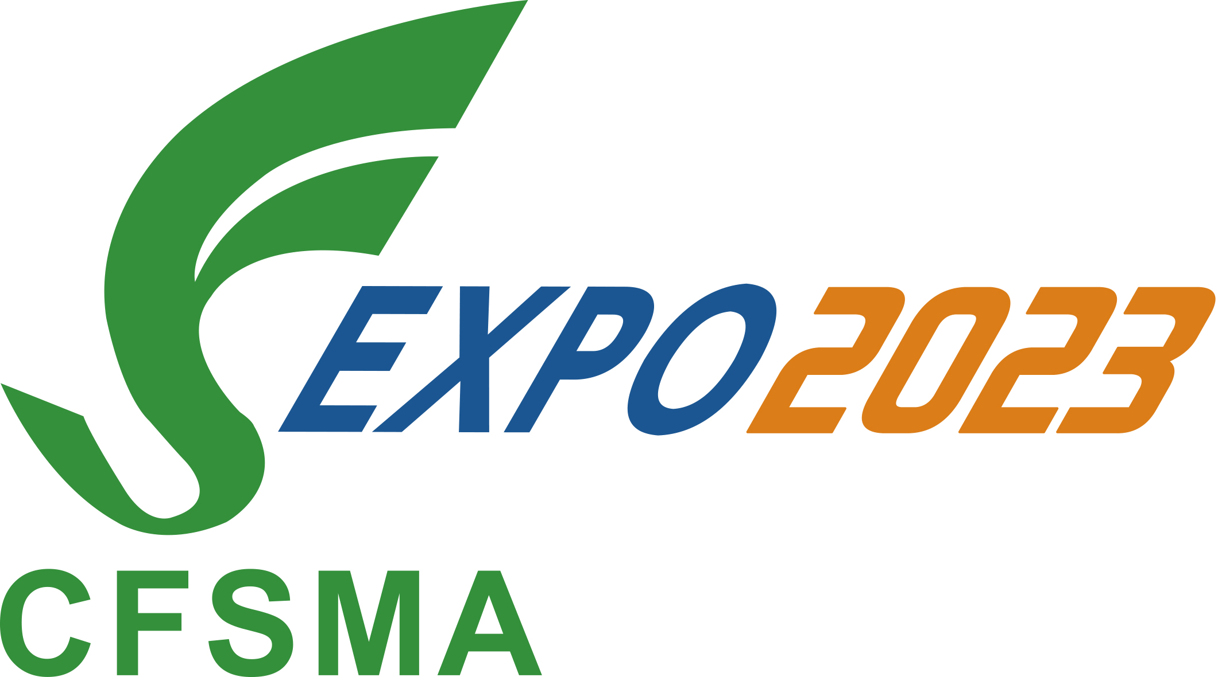

The 25th International Friction & Sealing Material Technology Exchange
and Product Exhibition
◆June 1st-3rd, 2023 ◆No.5 Hall in Xi’an International Convention and Exhibition Center

Company  Details | Company Name：
Company  Details | Contact Person：
Company  Details | Tel： | Fax：
Company  Details | E-mail：
Reservation Hotel | We will arrange the delegates to stay Jinjiang International Hotel in Xi’an, with the agreed price of a single room at 539 yuan/room (including one breakfast)and standard room at 638 yuan/room (including two breakfast). Please contact Mr. Sun, 13609198817 (Accommodation expenses shall be borne by self)
Participate  OR  Exhibit | Name： Position： Tel：
Participate  OR  Exhibit | Name： Position： Tel：
Participate  OR  Exhibit | Standard Booth Reservation ：1□ 2□ 3□ 4□ 5□ 6□ 7□ 8□  Booth Number ：  ___________________________________________________________________
Participate  OR  Exhibit | Company Profile：  We have half-page advertising space (350words) in "Exhibitor Book" as free gifts for each booth. Please provide a short paragraph about your company, and send to us.(cfsma9@126.com)
Company’s  Booking  proposal | (Leader’s signature or company seal)

