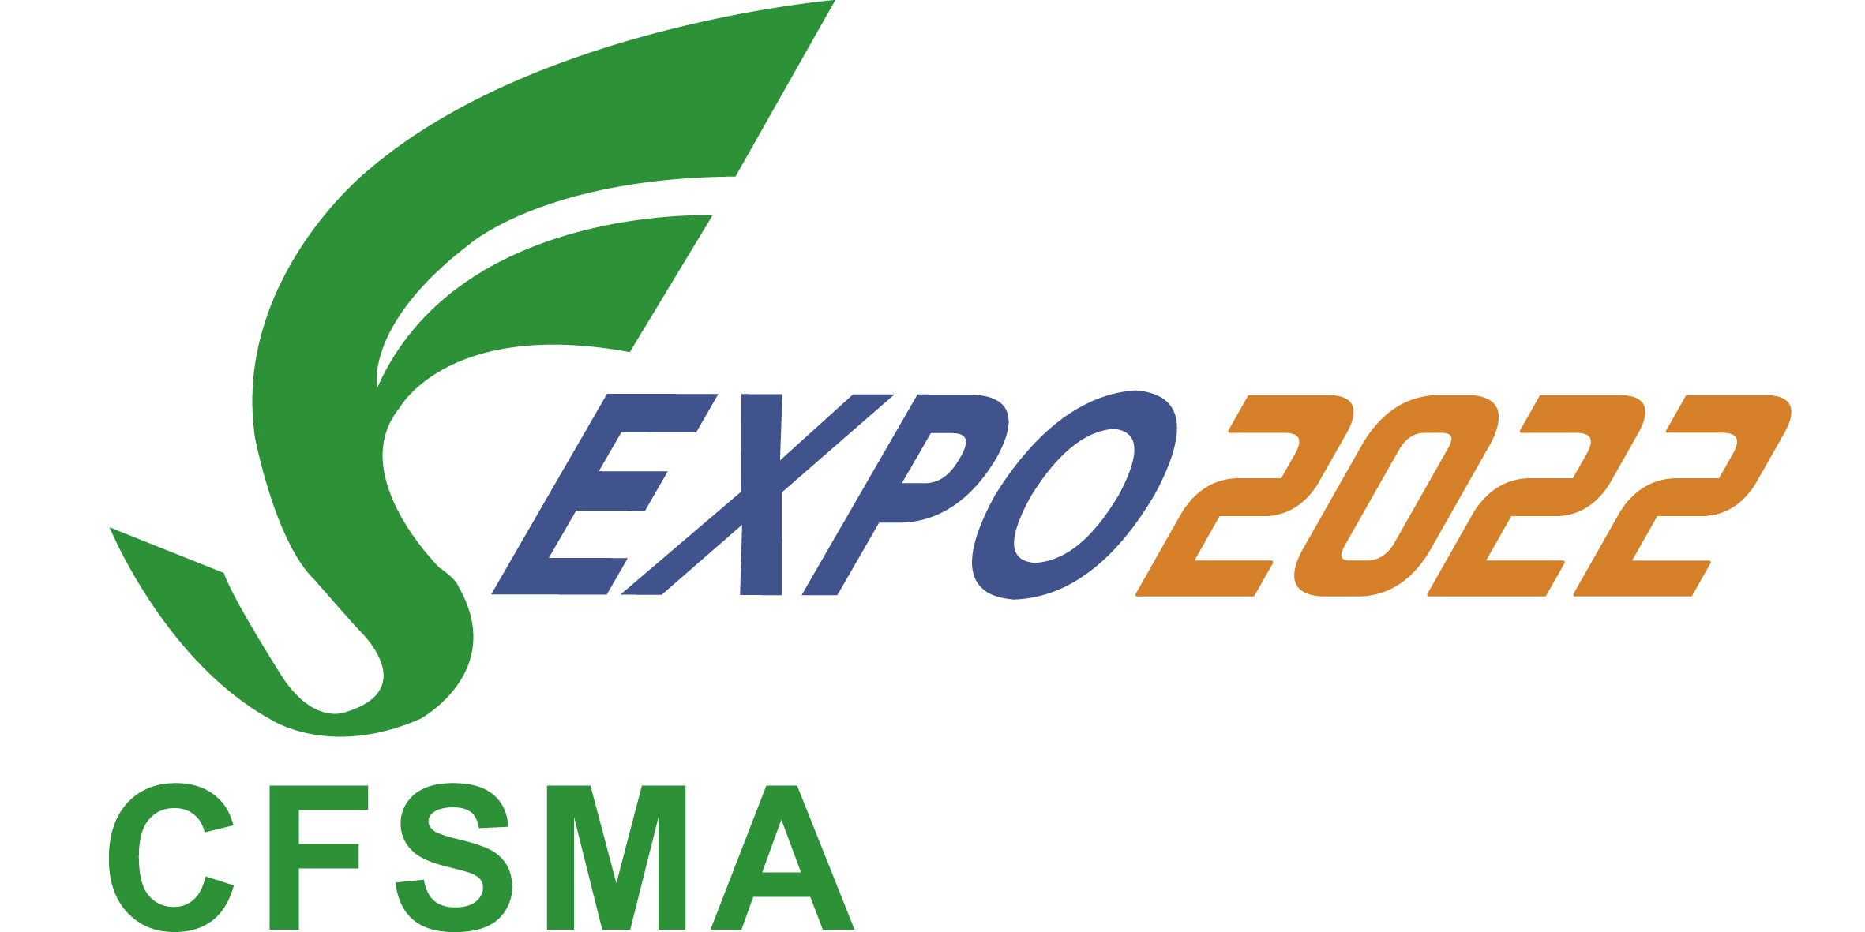

The 24th International Friction & Sealing Material Technology Exchange
and Product Exhibition
◆July 6th-8th, 2022 ◆First Floor in Luoyang Convention and Exhibition Center

Company  Details | Company Name：
Company  Details | Contact Person：
Company  Details | Tel： | Fax：
Company  Details | E-mail：
Reservation Hotel | ※Total RMB 579, with breakfast  Huayang Plaza Hotel - Luoyang  No.1 Liaoning Road, Jianxi District, Luoyang City, Henan Province, China  Beijing Hanyuan Jincheng Advertising Media Co. Ltd is entrusted to take charge of the accommodation for 2022 Exhibition. For accommodation reservation, please contact Wang Song (13520205319, same number as We Chat), the person in charge of hotel reservation of the company.
Participate  OR  Exhibit | Name： Position： Tel：
Participate  OR  Exhibit | Name： Position： Tel：
Participate  OR  Exhibit | Standard Booth Reservation ：1□ 2□ 3□ 4□ 5□ 6□ 7□ 8□  Booth Number ：  ___________________________________________________________________
Participate  OR  Exhibit | Company Profile：  We have half-page advertising space (350words) in "Exhibitor Book" as free gifts for each booth. Please provide a short paragraph about your company, and send to us.(cfsma9@126.com)
Company’s  Booking  proposal | (Leader’s signature or company seal)

